**Title** : Study of LED TV .

**Introduction** :

LEDs have come a long way since the early days of lighting up digital clock faces. In the 2000s, LCD TVs took over the high definition market and represented a huge step over old standard definition CRT televisions. LCD displays were even a major step above HD rear-projection sets that weighed well over 100 pounds (45.4 kilos). Now LEDs are poised to make a similar jump. While LCDs are far thinner and lighter than massive rear-projection sets, they still use cold cathode fluorescent tubes to project a white light onto the pixels that make up the screen. Those add weight and thickness to the television set. LEDs solve both problems. In this experiment LED-backlit TV technology, the pros and cons of this technology and comparisons with other high definition technologies are briefly discussed.

**Working Principle:**

**Liquid Crystal:** Liquid crystals are a state of matter which has properties between those of conventional liquids and those of solid crystals. For instance,a liquid crystal may flow like a liquid, but its molecules may be oriented in a crystal like way.

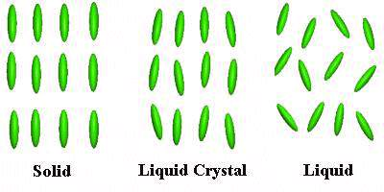

**Figure: Different state of matter including liquid crystal**

**Polarizer:** A polarizer is an optical filter that lets light wave of a specific polarization pass through while blocking light of other polarization. It can convert a beam of light of undefined or mixed polarization into a beam of well-defined polarization, that is polarized light. The common types of polarizers are linear polarizers and circular polarizers. Polarizers are used in many optical techniques and instruments, and polarizing filters find applications in photography and LCD technology. Polarizers can also be made for other types of electromagnetic waves besides light, such as radio waves, microwaves and X-rays.

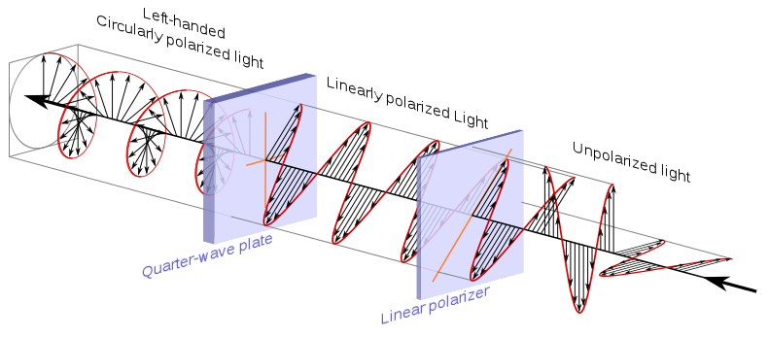

**Figure: Polarizing light with circular polarizer and Linear polarizer**

**LCD and LED technology:**

**Operating Principle of LCD technology:** he principle behind the LCD’s is that when an electrical current is applied to the liquid crystal molecule, the molecule tends to untwist. This causes the angle of light which is passing through the molecule of the polarized glass and also cause a change in the angle of the top polarizing filter. As a result a little light is allowed to pass the polarized glass through a particular area of the LCD. Thus that particular area will become dark compared to other. The LCD works on the principle of blocking light. While constructing the LCD’s, a reflected mirror is arranged at the back. An electrode plane is made of indium-tin oxide which is kept on top and a polarized glass with a polarizing film is also added on the bottom of the device. The complete region of the LCD has to be enclosed by a common electrode and above it should be the liquid crystal matter.

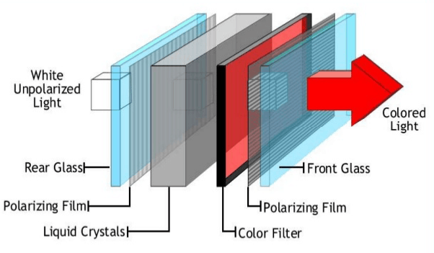

**Figure: How LCD works**

Next comes to the second piece of glass with an electrode in the form of the rectangle on the bottom and, on top, another polarizing film. It must be considered that both the pieces are kept at right angles. When there is no current, the light passes through the front of the LCD it will be reflected by the mirror and bounced back. As the electrode is connected to a battery the current from it will cause the liquid crystals between the common-plane electrode and the electrode shaped like a rectangle to untwist. Thus the light is blocked from passing through. That particular rectangular area appears blank.

**Operating Principle of LED technology**: A light-emitting diode is a two-lead semiconductor light source. It is a p–n junction diode that emits light when activated. When a suitable voltage is applied to the leads, electrons are able to recombine with electron holes within the device, releasing energy in the form of photons.

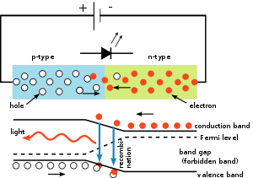

**Figure: How LED works**

This effect is called electroluminescence, and the color of the light (corresponding to the energy of the photon) is determined by the energy band gap of the semiconductor.

**Shutter & filter:** LCD televisions produce a colored image by selectively filtering light produced by a [backlight](https://en.wikipedia.org/wiki/Backlight), originally provided by a series of [cold cathode fluorescent lamps](https://en.wikipedia.org/wiki/Cold_cathode) (CCFLs) but now typically by white or colored [LEDs](https://en.wikipedia.org/wiki/LED). Millions of individual LCD shutters, arranged in a grid, open and close to allow a metered amount of the white light through. Each shutter is paired with a colored filter to remove all but the red, green or blue (RGB) portion of the light from the original white source. Each shutter–filter pair forms a single sub-pixel. The sub-pixels are so small that when the display is viewed from even a short distance, the individual colors blend together to produce a single spot of color, a [pixel](https://en.wikipedia.org/wiki/Pixel). The shade of color is controlled by changing the relative intensity of the light passing through the sub-pixels.

**Director :** Liquid crystals comprise a broad array of rod-shaped polymers that naturally form into thin, ordered layers, as opposed to the more random orientation of a normal liquid. Some of these, the nematic liquid crystals, also show an alignment effect between the layers. The particular direction of the alignment of a nematic liquid crystal can be set by placing it in contact with an alignment layer or director, which is essentially a material with microscopic grooves in it, on the supporting substrates. When placed on a director, the layer in contact will align itself with the grooves, and the layers above will subsequently align themselves with the layers below, the bulk material taking on the director's alignment. In the case of a Twisted Nematic (TN) LCD, this effect is utilized by using two directors arranged at right angles and placed close together with the liquid crystal between them. This forces the layers to align themselves in two directions, creating a twisted structure with each layer aligned at a slightly different angle to the ones on either side.

**Applications of LCD and LED :**

**LCD:**

1. The liquid crystal displays (LCDs) are used in aircraft cockpit displays.

2. It is used as a display screen in calculators.

3. For displaying images used in digital cameras.

4. The television is main applications of LCD.

5. Mostly the computer monitor is made up of LCDs.

6. It is used in instruments panel where all the lab instruments uses LCD screens for display.

7. The LCDs are commonly used in all the digital wrist watches for displaying time.

8. The LCDs are used in mobile screens.

9. It is also used in video players.

**LED:**

1. In motor vehicles and bicycle lights.

2. In traffic light Indicators, signs and signals.

3. In data displaying boards.

4. In medical applications and toys

5. Non visual applications.

6. In light bulbs and many more.

7. Remote controls

8. In Television

**Diffrerences Between LED and LCD:**

| Basis For Comparison | LED | LCD |
| --- | --- | --- |
| Definition | PN-Junction device which discharge visible lights when an electrical charge passes through it. | It is an optical device used for displaying the information in the form of text and images. |
| Stand For | Light Emitting Diode | Liquid Crystal Display |
| Backlight | No backlight | Cold cathode fluorescent lamp provides backlight. |
| Resolution | High | Low |
| Power Requirement | More | Less |
| Display Area | Small | Large |
| Cost | High | Low |
| Material | Gallium arsenide phosphide. | Liquid crystals and glass electrodes. |
| Switching Time | Fast | Slow |
| Direct Current | Do not effects. | Reduces Life Span |
| Contrast Ratio | Low | High |
| Mercury | Not used | Used |

**Types of LED :**

**Edge-lit LEDs:** In which the LEDs are formed around the rim of the screen, using a special diffusion panel to spread the light evenly behind the screen (the most common use). The only real advantage afforded by these sets is thinness. Most LED-edgelit panels consist of two major components: A long LED module with a row of tiny white diodes and a thin screen-sized plastic sheet known as a light guide plate. Two LED modules are deployed along the top and bottom of the panel. The combined light output is then funneled and spread out across the screen. Technically, an edgelit LED system lacks finer backlight control compared with the backlit version. Uneven backlight uniformity is another common shortcoming. To put this into perspective, a backlit panel can turn on selected LEDs to bring out the sparkle of stars in a galaxy while switching off the remaining bulbs to produce deep blacks for the background. Edgelit panels are usually less capable in this aspect.

**LED backlighting (Full array)**: Behind the screen, whose brightness is not controlled individually. It provide improved color

**Dynamic “local dimming” backlight:** LEDs controlled individually (or in clusters) to control the level of light/color intensity in a given part of the screen to create a more dynamic picture. And that highlights one more great advantage of LEDs over compact fluorescent lights: Because the LEDs can actually be instantly toggled on and off, they produce awesome black levels in dark scenes. Since the white fluorescent lamps have to remain on during TV use, some light tends to bleed through and lighten the picture in dark scenes.

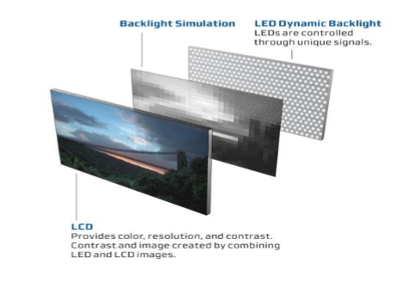

**Figure: Dynamic Backlight LED**

**Discussions:**

**Advantages and Disadvages of LED televisions:**

**Advantages:**

1. Picture Quality: This is an important advantage with **LED TV** over LCD televisions. You will be able to see a better picture quality if you use LED Television which is better than LCD TV. The black levels are improved a lot and you will see blackest colors. And since a LED TV uses LED ( light emitting diodes), the brightness is significantly improved over normal LCD televisions which use fluorescent bulbs.

2. Energy efficiency: Besides better picture quality, **LED Televisions** are also energy efficient. They consume very less energy compared to LCD televisions. There is almost 50% reduction in the power consumption for LED televisions.  
3. The contrast is much better in **LED TV** compared to LCD television

4. The life span of LED TV is better than LCD televisions  
5. Like LCD televisions, mercury is not used for lighting the display panel in LED television.

6. A LED TV is the most reliable compared to LCD television or a plasma TV

**Disadvantages:**

1. Price: LED Televisions are quite expensive when compared to LCD TV or a plasma TV. It is almost twice the cost of a LCD television.  
2. It is difficult to mount the LED TV on the wall as they have more dimensional depth.  
3. Compared to plasma TVs, LED TV do not have better Contrast ratio  
4. Price / value is better for a plasma television compared to LED TV

**Recent Innovations:**

**OLED:** OLEDs are solid-state devices composed of thin films of organic molecules that create light with the application of [electricity](https://science.howstuffworks.com/electricity.htm). OLEDs can provide brighter, crisper displays on electronic devices and use less power than conventional [light-emitting diodes](https://electronics.howstuffworks.com/led.htm) (LEDs) or [liquid crystal displays](https://electronics.howstuffworks.com/lcd.htm) (LCDs) used today.

**4K:** 4K (or Ultra HD as it's also confusingly known) has enough pixels to fill four Full HD 1080p screens. With four times the amount of pixels it's able to display four times the level of detail.

**8k:** 8K is nothing short of the clearest picture you’re ever likely to see. It’s got four times more pixels than 4K images, measuring 7680x4320 pixels, which equates to a total of 33,177,600 pixels. In a 65-inch screen they are so small you won't even be able to make out the pixel structure. However, many 8K TVs are much larger.

**Conclusion:** OLED, QLED, 4k,8K ultra-HD, touch-sensitive flexible screens, virtual reality — it’s enough to make us pant with anticipation for the possibilities of the future and how we interact with TV. Even better yet, all this technology can be and is being used in today’s TVs to make them lighter, thinner and more interactive than ever.

**References:**

1) How stuff works website, Available: www.electronics.howstuffworks.com

2) CNET Asia Website, Available: [www.asia.cnet.com](http://www.asia.cnet.com)

3) Electronics Repair Website, Available: <http://www.jestineyong.com/>

4) Circuit Globe Website, Available: <https://circuitglobe.com/difference-between-led-and-lcd.html>

5) Electronics hub website, Available: <https://www.electronicshub.org/light-emitting-diode-basics/>

6) Polytechnic hub website, Available: <https://www.polytechnichub.com/applications-lcd-liquid-crystal-display/>

7) Wikipedia, Available : <https://en.wikipedia.org/wiki/Liquid_crystal>

8) Thoughts From Geeks , Available: <http://www.thoughtsfromgeeks.com/resources/2974-Advantages-And-Disadvantages-LED-Televisions-how-different-from.aspx>

9) Tech radar website, Available: <https://www.techradar.com/news/television/ultra-hd-everything-you-need-to-know-about-4k-tv-1258884>

10) Dish Website , Available: <https://www.dish.com/dig/technology/4-technology-innovations-guaranteed-to-change-the-future-of-tv/>